C:\Program Files (x86)\Microsoft Office\MEDIA\CAGCAT10\j0088542.wmf

Cerenity Marian Social



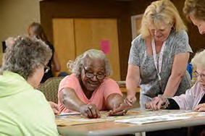

Enjoy an afternoon of cards,

Bring a friend

Double the fun!

games and conversation.

Bring a friend

Double t fun!

And, by the way, stay for pie

**Cerenity Marian Residence**

**Sidewalk Café**

**Tuesday, Feb. 19**

**1:30 pm**



Join us for Catholic Mass at

1 pm in Marian chapel

Prior to social time.

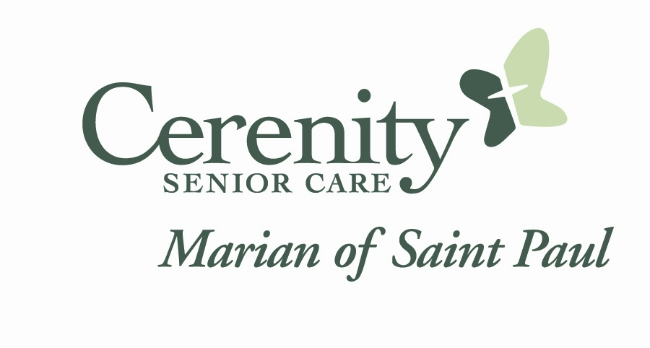

C:\Program Files (x86)\Microsoft Office\MEDIA\CAGCAT10\j0088542.wmf